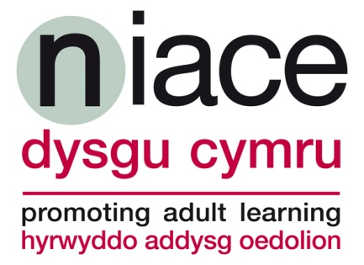

Changing Lives: Tackling Poverty – The Impact of Adult Learning

Tuesday, 21 May 2013
Holiday Inn, Cardiff City Centre

A Conference for Adult Learners’ Week 2013 in partnership with:
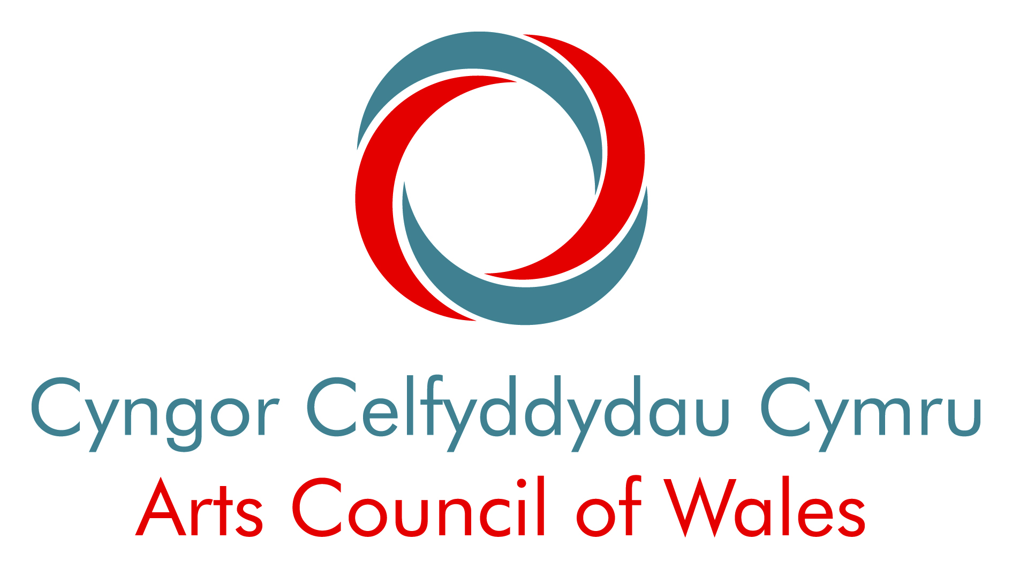 |  | 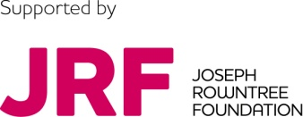

Supported by the Bevan Foundation
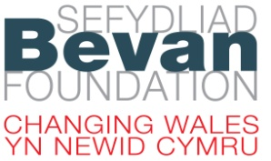

Adult Learners’ Week is a celebration of the impact that adult learning makes in Wales and serves as a powerful reminder of the contribution it can make in developing confident, vibrant and successful communities. The campaign also provides an opportunity to ask questions about who is participating in learning, how we are providing opportunities to develop the confidence and skills of our communities and what we could be doing differently.
In June 2012 Welsh Government launched their Tackling Poverty Action Plan with a commitment to prioritising the needs of the poorest and protecting those most at risk of poverty and exclusion; this year new Communities First Clusters will begin delivering their action plans to secure prosperous, learning and healthier communities.
NIACE Dysgu Cymru is pleased to be working in partnership with the Arts Council of Wales, Community Housing Cymru, Cooperative Membership and the Joseph Rowntree Foundation to deliver this conference.
Those attending will have the opportunity to feed into the Welsh Government Tackling Poverty Action Plan, to hear about the Development Plans of Communities First Clusters, listen to the learning stories of individuals, participate in workshops and discuss ideas for new ways of working.
The Bevan Foundation is supporting this event and will have information about the Wales Education and Poverty Network, which aims to bring together people and organisations committed to breaking the influence of poverty on educational participation and achievement in Wales.

This event will be of interest if you are:

- Communities First Co-ordinators
- Community learning , Further/High Education adult learning practitioners
- TUC/WULF Project Managers
- 3rd Sector organisations and charities
- Social housing representatives
- Community Arts practitioners or working in museums, archives and libraries.

Programme

09.30 Arrival and Registration

10.15 Welcome: Richard Spear, NIACE Dysgu Cymru

10.20 Learner Stories: Transforming lives, families and communities discussion/ film clips

10.40 Kate Cassidy, Director for Communities & Tackling Poverty Welsh Government

11.00 David Hughes, NIACE Poverty & Equality: Making the case for adult learning - the value of adult learning to social/economic policy

11.20 David Egan, Tackling Poverty Advisory Group

11.40 Panel Discussion / Question Time: Chair, Victoria Winckler, Bevan Foundation/ Joseph Rowntree Foundation

12.00 Tea/Coffee Break

12.15 Break-out sessions Sharing Ideas, Inspiring Action

13.00 Lunch/ networking

13.45 Summary of morning discussions – setting the scene for afternoon –
Richard Spear, NIACE Dysgu Cymru
13.50 Adult Learning in Difficult Times, Poverty and Learning, Simon Beer, NIACE
14.05 Widening participation in learning – engaging those most in need: Strategies from Adult Community Learning, Wendy Edwards, Head of Adult Education, Rhondda Cynon Taf, Laura Phillips, Springboard Co-ordinator, Learning Pembrokeshire
14.20 Break- out sessions Sharing Ideas, Inspiring Action
15.00 Third Sector Anti-Poverty Programmes Taskforce – opening up Structural Funds to develop innovative adult learning programmes, Helen Wilkinson, WCVA
15.15 Round table discussions – working together to engage those most in need, recommendations for the Tackling Poverty Action Plan
15.35 Feedback – key messages to influence policy and shape future working
15.45 Refreshments/Depart

Break-out sessions:

- Learning where you live: strategies to engage tenants within social, supported housing across Wales.
- Oxfam’s Sustainable Livelihood Toolkit for Wales: The Sustainable Livelihoods Approach is a method of understanding the lives of people experiencing poverty and disadvantage.

- Engaging individuals, through creative practice: Valley and Vale Community Arts share their Stepping Forward project and workshop methods, working with people with mental health issues.

- Reach Further with Connecting Learners – Connecting Learners, a Wales Union Learning Fund (WULF) project organised by Unison, showcases some of its learner stories and discusses how union-led learning can help you to develop the skills of your organisation.

- Adult Learning in Difficult times: A look at NIACE’s 6 pathfinder projects in England (debt in Birmingham, youth unemployment in Bristol, unemployment and welfare reform in south London, sustaining employment in Redbridge, in-work poverty in Hull, rural poverty in Herefordshire).

- Delivering Prosperous, Learning, Healthier Communities: Partnerships between Adult Community Learning and Communities First Clusters to engage individuals, families and communities.

